Whole School Curriculum Overview

 | Autumn 1 | Autumn 2 | Spring 1 | Spring 2 | Summer 1 | Summer 2
EYFS | 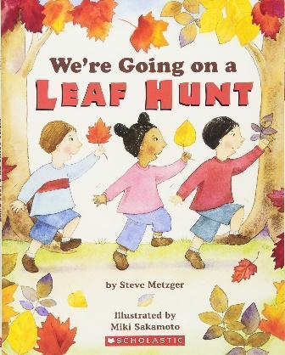 | 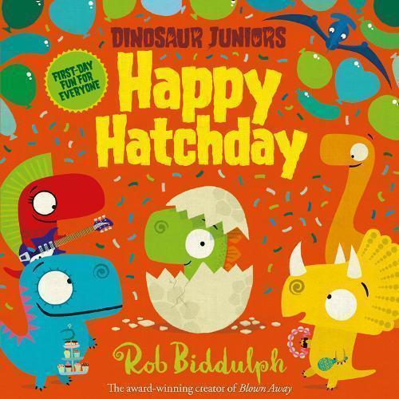 | 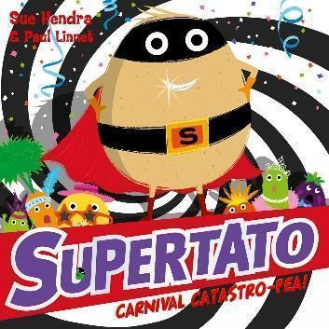 | 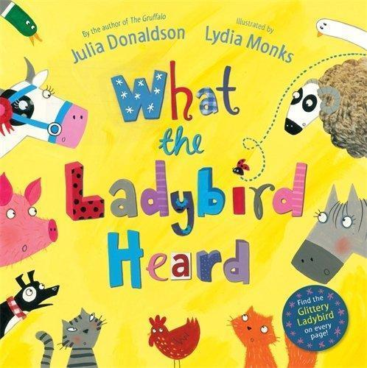 | 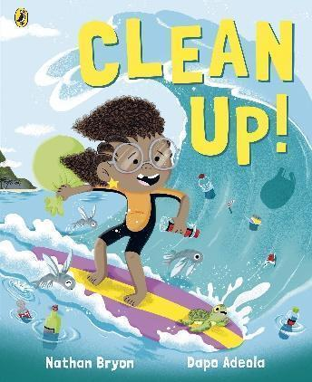 | 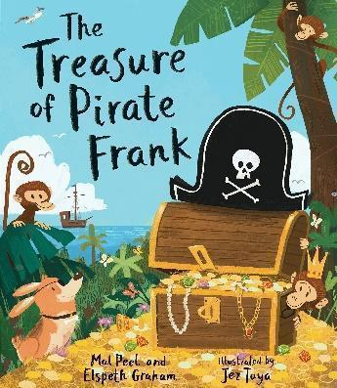
Communication & Language | Listen attentively to simple stories and instructions; respond with relevant comments or questions; begin to engage in short back-and-forth exchanges with peers and adults.  Use new vocabulary in simple phrases; contribute ideas in small groups or one-to-one discussions with support. | Continue to listen attentively to longer stories and explanations; ask questions to clarify understanding; contribute more consistently to group discussions.  Begin explaining reasons for actions or events using recently introduced vocabulary; extend contributions in small group discussions. | Listen to more complex stories and explanations; recall key details; respond appropriately to peers’ ideas in back-and-forth conversations.  Express ideas in longer sentences; start using past, present, and future tenses with teacher support; participate actively in discussions. | Make comments about what they have heard; ask clarifying questions; engage confidently in group and one-to-one discussions.  Use conjunctions to link ideas; explain experiences and thoughts using recently introduced vocabulary; engage confidently in group discussions. | Show sustained attention during longer stories and discussions; anticipate key events; use listening skills to follow instructions  Independently.  Speak in full sentences about experiences; provide explanations for why things happen; use a range of recently introduced vocabulary independently. | Demonstrate full engagement in discussions; hold longer conversations with peers and adults; express understanding clearly.  Demonstrate confident and fluent speech in discussions; explain ideas clearly; use appropriate tense and vocabulary consistently.
Reading | Say a sound for each letter and begin learning simple digraphs; blend sounds to read simple words.  Retell simple stories in own words; begin to use recently introduced vocabulary in discussions. | Read words using phonic knowledge; begin reading simple sentences; learn some common exception words.  Anticipate key events in familiar stories; discuss stories using recently introduced vocabulary. | Blend sounds to read unfamiliar words; read simple sentences independently; recognise increasing number of exception words.  Retell longer stories with key details; use new vocabulary confidently in discussion. | Read aloud simple sentences and books; apply phonic knowledge to decode unfamiliar words.  Explain story events and characters’ actions; participate in role-play using story language. | Read longer sentences and short texts fluently; use phonics skills to read unfamiliar words.  Discuss non-fiction texts; express understanding using newly learned vocabulary; anticipate outcomes. | Read age-appropriate texts fluently; demonstrate confidence in decoding and word recognition.  Demonstrate understanding across a range of texts; discuss and retell confidently using a wide vocabulary.
writing | Hold the pencil using a tripod grip with support; begin using scissors, paintbrushes, and cutlery with some accuracy. Start making marks to represent sounds they know.  Write some recognisable letters. | Use pencil and small tools with increasing accuracy; show care in drawing and cutting activities. Begin to form recognisable letters.  Write letters more accurately; spell words by segmenting sounds; ; write simple phrases with support. | Write letters more accurately; use small tools with confidence; demonstrate improved control.  Use phonics to spell words. Form some capital letters correctly. Begin forming simple sentences with support. | Hold pencil effectively in most cases; draw and cut with accuracy and care; Form recognisable letters including some capital letters.  Write phrases and sentences that can be read by others. | Use pencil and tools independently; write most letters correctly; show precision in drawing and cutting tasks.  Write short sentences; spell increasingly complex words using phonics knowledge. | Show fluent pencil control; use scissors, paintbrushes, and other tools competently; write recognisable letters consistently.  Write longer sentences. Create simple stories; demonstrate accurate letter formation and phonics-based spelling.
Year 1 | 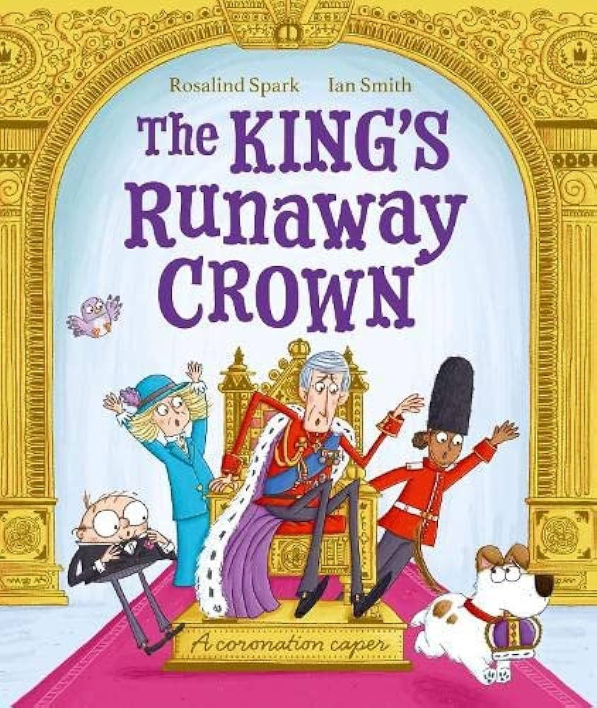 | 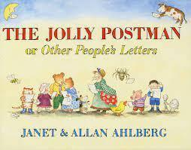 |  | 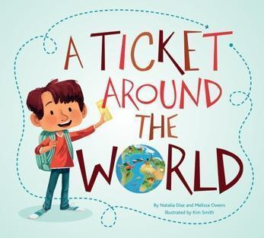 | 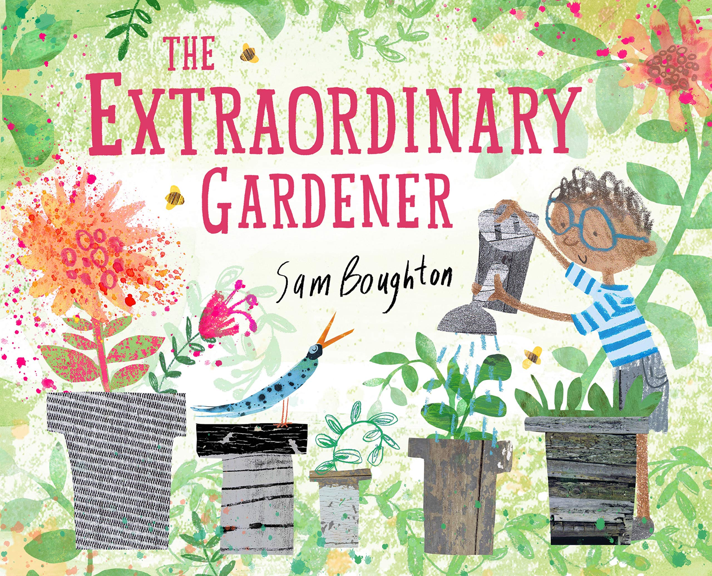 | 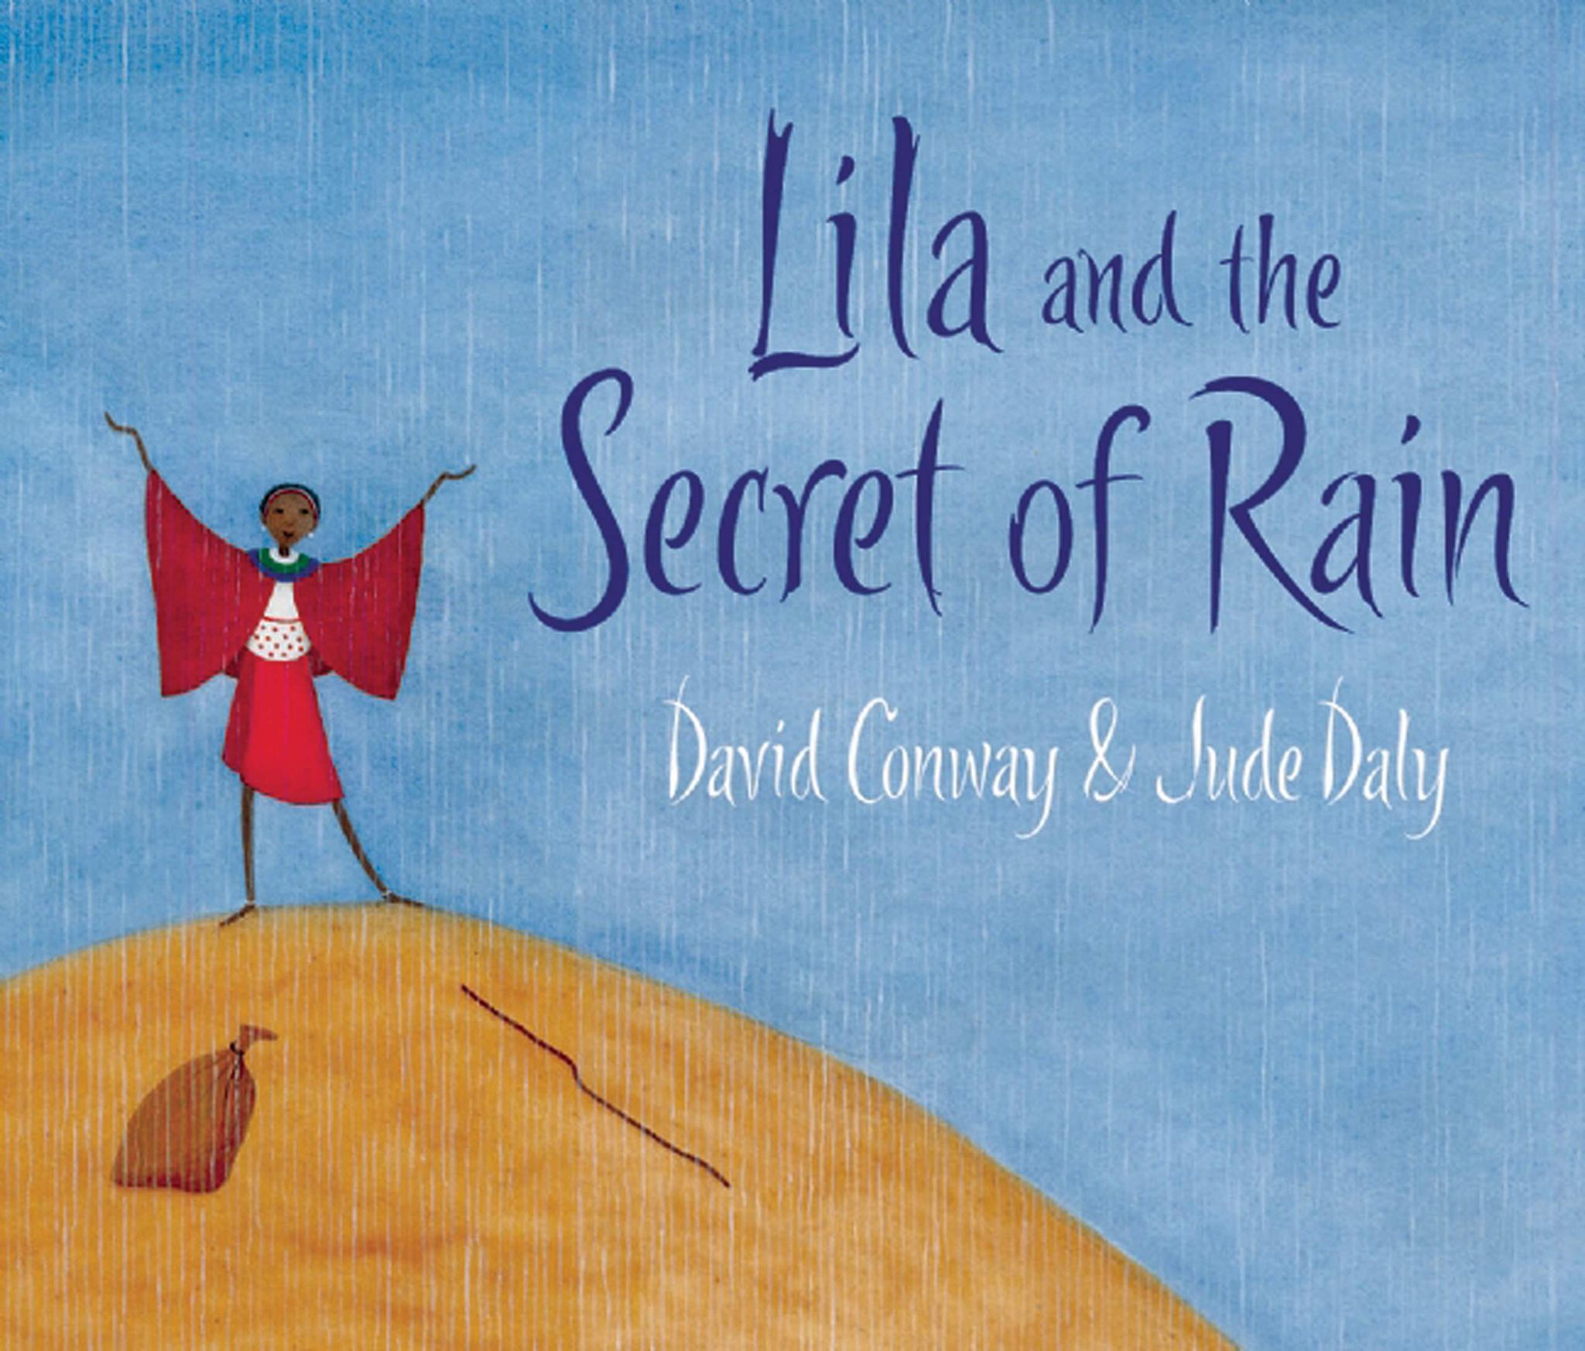
Purpose and outcome | To inform  Labels and caption  Recount fact or fiction | To narrate/entertain  Traditional Tales  End write is a letter to Santa | To narrate/entertain  Stories from a familiar setting | To inform  Information Text | To inform/ entertain  Stories from a familiar setting that include factual information | To narrate/entertain  Stories from another culture
Poetry | writing rhyming words  Poems on a theme  Autumn Days by Brenda Williams.  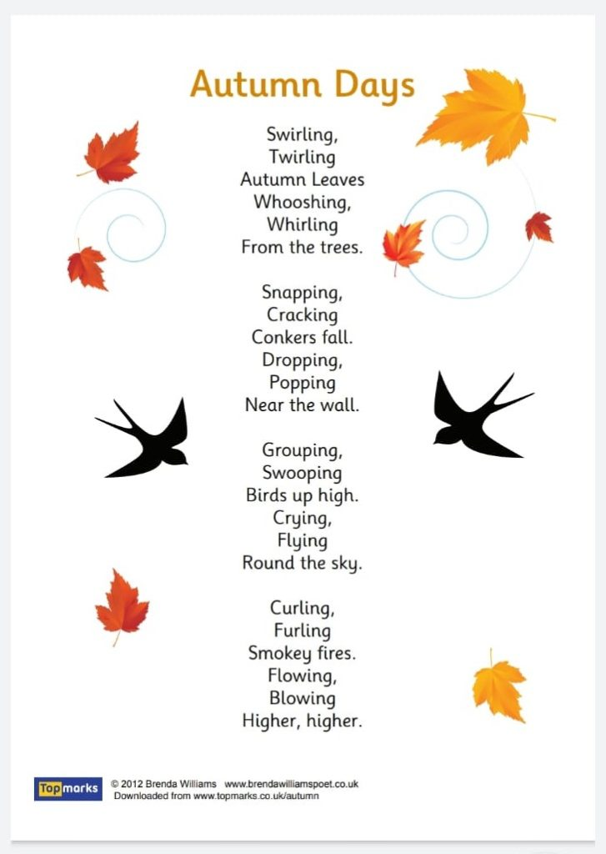  Discuss rhyming words emphasising the end sound.  Children To predict some missing words from the poem by selecting a word that could rhyme. | Performance  Repetition  I’ve Been Waiting for Christmas  Author Unknown  https://www.loveliveson.com/christmas-poems-for-kids/#ChristmasPoemsforKidsAged6to12anchor | Performance  Rhyming verse  Mischievous Toys Poem by Kim Barney  https://www.poemhunter.com/poem/mischievous-toys/ | Write  Rhyme  Where Do You Get Your Ideas?  Pie Corbett  https://www.talk4writing.com/wp-content/uploads/2020/01/Pie-Where-Do-You-Get-Your-Ideas-edited.pdf  https://www.talk4writing.com/resources/poetry/ | Poetry by heart  Rhyme  In The Tree's Defence - A.F. Harrold  https://poetrybyheart.org.uk/poems/in-the-trees-defence | R.E. Global World  our neighbours  Repetition  People need people - Benjamin Zephaniah’s  Book  poet reading  https://www.youtube.com/watch?v=8uHHjAsPbLc
Spoken Language | 1. Listen and respond appropriately to  adults and their peers  Able to concentrate on the person talking and to ignore background noise and movement which is not relevant to the situation.  Understand 2-3 part instructions that may include time concepts, e.g. using ‘first’, ‘before’, ‘after’ or ‘when’  e.g. ‘Before you sit down you need to hang up your coat and wipe your feet.’  2. Ask relevant questions to extend their understanding and knowledge  Ask questions to find out things using ‘how’ and ‘why’ when prompted  e.g. ‘Can you think of a ‘why’ question about this story?’ – ‘Why does Harry go to the island of the monsters?’  Be aware when they haven’t understood something and are able to say, for example, ‘I don’t understand’ (with no further elaboration).  3. Use relevant strategies to build their vocabulary  Able to group and name members of categories and to suggest possible category names  e.g. ‘Horse, cow and pig are all mammals’; ‘Pen, pencil and ruler are stationery’; ‘Rain, snow and sunshine are types of weather.’  Able to guess the word from clues, or give others clues using shape, size, function, etc. with support  e.g. ‘It is long and wriggly and makes a hissing sound.’; ‘It is found in the kitchen, it has a handle and a lip and you might put milk in it.’  4. Articulate and justify answers, arguments and opinions  Use language consistently to express likes and dislikes  e.g. ‘I don’t like using sticky clay.’  5. Give well-structured descriptions, explanations and narratives for different purposes, including for expressing feelings  Able to use early ‘story language’  e.g. ‘Once upon a time …’; ‘One day, ...’  Use language to talk through a series of steps for example for simple problem solving  e.g. ‘I don’t have enough paint to finish my picture. I’m going to borrow some from another table.’  Able to join sentences using ‘and’  e.g. ‘I went shopping and I bought some apples.’ |  |  | 6. Maintain attention and participate actively in collaborative conversations, staying on topic and initiating and responding to comments  Maintain attention and participate in conversation and small groups providing there are minimal external distractions.  Attention and participation in larger groups is sustained for most of the activity.  7. Use spoken language to develop understanding through speculating, hypothesising, imagining and  exploring ideas  Use language to talk self through steps required in simple problem solving  e.g. ‘I have to get all the Lego bricks and sort them out. I need to find all the black ones. Then I can  start making this monster.’  8. Speak audibly and fluently with an increasing command of standard English  Produce speech that is clear and easy to understand, with only a few immaturities  e.g. ‘w’ instead of ‘r’, ‘f’ instead of ‘th’, complex consonant blends e.g. ‘sc’ instead of ‘scr’.  Able to say words accurately with 3 syllables or less I can say words with up to 3 syllables clearly.  Able to blend 3 or 4 phonemes to make a word, and segment words into individual sounds I can blend sounds out loud to make a short word.  Able to use appropriate tenses and word order  e.g. ‘The girl walked to school’ or ‘Tomorrow I will be on holiday.’  9. Participate in discussions, presentations, performances, role play, improvisations and debates  Remember their words and speak clearly in presentations, performances and role play I can speak clearly in presentations, performances and role plays when I have just got a bit to say.  10. Gain, maintain and monitor the interest of the listener(s)  Able to initiate a conversation with a class visitor by using prepared questions I can ask a class visitor questions that I have already thought of.  11. Consider and evaluate different viewpoints, attending to and building on the contributions of others  Respond to points of interest when listening to contributions of others  e.g. ‘Oh I have been to Brighton Pier as well. Did you go on the helter-skelter?’  12. Select and use appropriate registers for effective communication Imitate popular language  e.g. ‘It’s cool’, ‘Hey mate!’, or ‘Have you seen James Bond? It’s wicked.’
Reading | Background Knowledge: Themed picture books to build knowledge.  Discuss themes  Vocabulary Knowledge: Discuss the books and explore the vocabulary..  Understanding Sentences: Construct simple sentences.  Using Text Structure: Identify beginning, middle, and end.  Explore story sequencing. | Activating Meaning: Explore picture cues to retell stories.  Activity example: Draw scenes from stories and explain.  Making Inferences: Infer feelings from pictures and simple text.  Comprehension Monitoring: Explain understanding of short stories through retelling stories in their own words. | Activating Meaning: Context clues for new words.  Making Inferences: Infer emotions/actions from text through activities such as role-play based on story events.  Comprehension Monitoring: Summarise and predict. | Background Knowledge: Themed non-fiction books.  Vocabulary Knowledge: group words by themes.  Understanding Sentences: Read and write compound sentences using "and" and "but".  Using Text Structure: Identify headings and captions in non-fiction. | Background Knowledge: Connect readings to personal experiences.  Vocabulary Knowledge: Discuss prefixes/suffixes within a text.  Understanding Sentences: Analyse and write varied sentences. | Activating Meaning: Graphic organisers for meaning using activities such as story maps and Venn diagrams.  Making Inferences: Infer character motivations.  Discuss characters' actions and reasons.  Comprehension Monitoring: Self-questioning techniques.  Students ask questions about the text as they read.
Grammar/ punctuatiom | Capital letters  Full stops  finger spaces  Nouns  Adjectives | Capital letters  Full stops  Nouns  Adjectives  Verbs  Conjunction ‘and | Capital letters  Full stops  Adjectives  Conjunction ‘and’ | Capital letters  Full stops  Adjectives  Conjunction ‘and’  Commas in lists  Question mark | Capital letters  Full stops  Adjectives  Conjunction ‘and’  Suffix ‘s’  Commas in lists  Exclamation mark | Capital letters  Full stops  Adjectives  Conjunction ‘and’  Exclamation mark  Suffix ‘es’  Question mark
Year 2 | 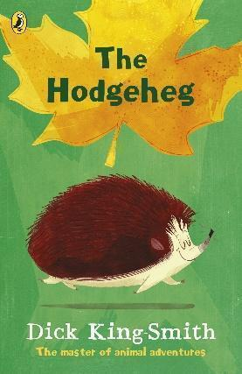 | 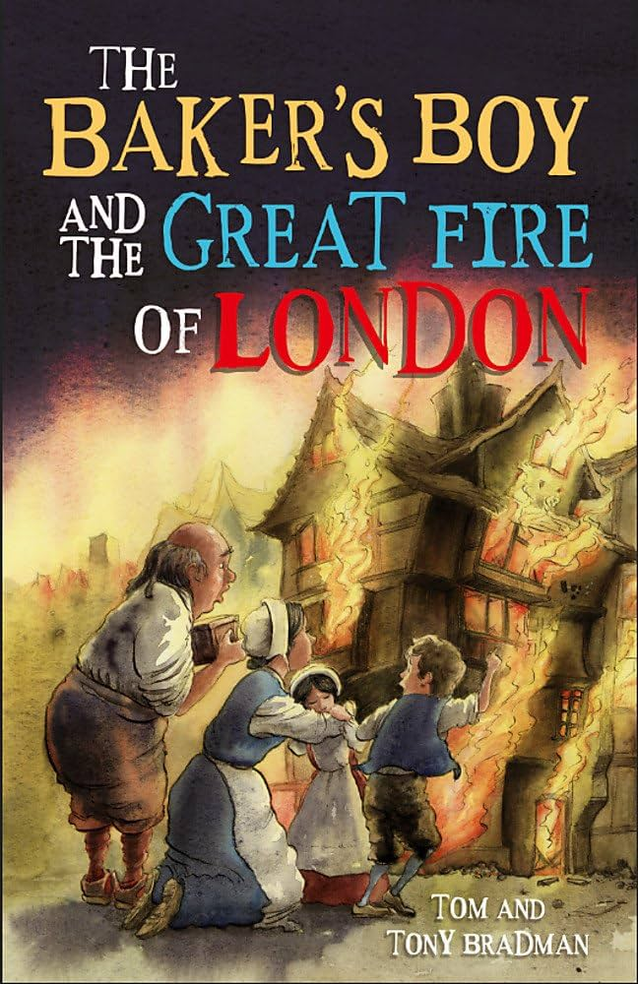 | 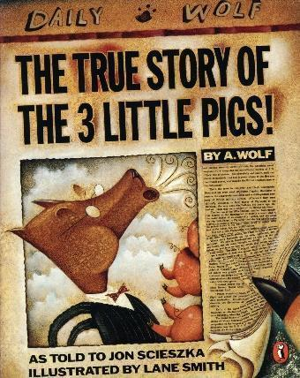 | 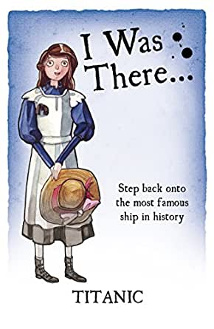 | 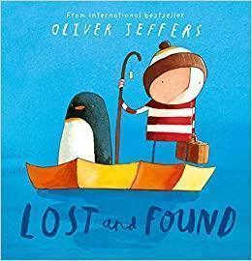 | 
Purpose and outcome | To inform/instruct  Stories with familiar settings, Instructions | To inform/recount  Information texts.  Diary recount entry. | To narrate/entertain  Traditional stories/ different viewpoints | To inform  Explanation texts  / non-chronological report  Persuasive writing | To narrate/ entertain  Significant authors,  Fantasy story | To narrate/inform  Adventure stories.  Non-chronological reports  Letters
Poetry | Write  basic Rhyme poetry  Today I saw a hedgehog by Graham Jones  https://www.poemhunter.com/poem/today-i-saw-a-hedgehog/ | Learn by heart. Alternative grapheme rhyme  Santa’s Watching  Author Unknown  https://www.loveliveson.com/christmas-poems-for-kids/#ChristmasPoemsforKidsAged6to12anchor | write - traditional tale as a poem  Rhyme  Birds Thoughts  https://etc.usf.edu/lit2go/74/nursery-rhymes-and-traditional-poems/5060/bird-thoughts/ | Performance  Lyrics/Rhyme  Titanic song  Daisy - Daisy | Performance  Repetition  After Dark By Michael Rosen  https://alanjwrightpoetrypizzazz.blogspot.com/2018/11/a-michael-rosen-poetry-prompt.html | R.E Global world  Being kind to our neighbours  A Simple Act Of Kindness Poem by David Harris  https://www.poemhunter.com/poem/a-simple-act-of-kindness/
Spoken Language | 1. Listen and respond appropriately to adults and their peers  Know the key points they need to focus on in order to answer a question  e.g. ‘Five buses have nine passengers each but the two trains are empty. How many passengers  altogether?’  Understand complex 2 – 3 part instructions  e.g. ‘Choose a character from the story we have just read, then talk to your partner about how they  feel at the end of the story and be ready to share your ideas.’  2. Ask relevant questions to extend their understanding and knowledge  Ask a range of different types of questions to find out specific information including ‘how’ and ‘why’  e.g. ‘How do we know the burglars can’t get in?’  Recognise when a message is not clear and be able to provide some information about why  e.g. ‘Can you say that again; you used too many words’ or ‘It was too fast.’  3. Use relevant strategies to build their vocabulary  Recognise when they haven’t understood a word or words and be able to provide some information  about why  e.g. ‘Can you say that again; you used too many words’ or ‘It was too fast.’  Able to compare words by the way they look, sound or their meaning, for example bare/bear, two/  to/too, and begin to comment on this  e.g. ‘If you had a bare bear then it wouldn’t have any fur!’; ‘Furious and angry mean the same thing.’  4. Articulate and justify answers, arguments and opinions  Use simple conjunctions to justify or explain something  e.g. ‘I am going to finish this picture because then I won’t have to do it for homework.’  5. Give well-structured descriptions, explanations and narratives for different purposes, including for  expressing feelings  Tell a story including setting the scene, a basic story plot and the sequence of events generally in  the right order  e.g. ‘Mum and the boy decided to go fishing. They put their things in the car. They drove to the lake.  They started fishing. Mum caught a big fish and fell in the water.’  Describe in 2-3 sentences how to solve a problem  e.g. ‘First I added up all the numbers. Then I worked out how many to make 50. Then I added 50 to  make 100, ‘cos that’s the same as £1.’  Able to use conjunctions to increase the length and grammatical complexity of sentences,  e.g. ‘because’, ‘when’. |  |  | 6. Maintain attention and participate actively in collaborative conversations, staying on topic and initiating and responding to comments  Take turns to talk, listen and respond in two way conversations and groups.  7. Use spoken language to develop understanding through speculating, hypothesising, imagining and exploring ideas  Accurately predict what will happen in a story or retelling of an event  e.g. ‘I think he is going to fall into the water because he is not looking where he is going.’  8. Speak audibly and fluently with an increasing command of standard English  Produce speech that is consistently clear and easy to understand, with very few immaturities  e.g. ‘f’ instead of ‘th’, complex consonant blends, e.g. ‘sc’ instead of ‘scr’.  Able to say words with 4 or more syllables fairly consistently.  Able to manipulate sounds in words such as deleting sounds from words  e.g. ‘What word do you get if you take away the ‘f’ sound from ‘feet’? Answer: ’eat’.  Know that there are some terms or expressions that are only used amongst friends e.g. ‘Hiya!’, ‘See ya later!’  9. Participate in discussions, presentations, performances, role play, improvisations and debates  Take turns to talk, listen and respond in two way conversations and groups.  10. Gain, maintain and monitor the interest of the listener(s)  Usually able to keep to the topic in a conversation.  Can be easily prompted to move on if they are talking too much I can let someone else take a turn in a  conversation when prompted.  11. Consider and evaluate different viewpoints, attending to and building on the contributions of others  Ask lots of questions to find out information and respond appropriately to the answers  e.g. ‘It is called evaporation? OK, then the answer is that the water will evaporate when it is heated up.’  12. Select and use appropriate registers for effective communication  Know that there are some terms or expressions that are only used amongst friends  e.g. ‘in your face’, ‘wicked’ and ‘yeah right’ with friends but not teachers.
Reading | Text Structure: Identify paragraphs by breaking a story into paragraphs.  Background Knowledge: Connect story themes to real life.  Vocabulary Knowledge: Find and discuss new words in context.  Understanding Sentences: Identify and verbally us complex sentences. Combine simple sentences into complex ones. | Background Knowledge: Make Links with cross-curricular readings that relate to the history topic Great Fire of London.  Making Inferences: Simple inferences about characters.  Discuss character actions and emotions.  Comprehension Monitoring: Retell and summarise. | Activating Meaning: Use pictures to guess word meanings.  Making Inferences: Simple inferences about characters.  Discuss character actions and emotions.  TEXT Structure: Identify beginning, middle, and end. | Background Knowledge: Make Links with cross-curricular readings that relate to the history topic on ships.  Vocabulary Knowledge: Explore subject specific vocabulary  Understanding Sentences: Discuss understanding of sentences using  unfamiliar words.  Text Structure: explore the use of headings and subheadings. | Using Text Structure: Compare text structures from the same author.  Making Inferences: Infer themes and messages within the texts.  Comprehension Monitoring: Self-questioning and summaries to monitor comprehension. | Background Knowledge: Relate readings to the Stone Age.  Vocabulary Knowledge: Explore how the vocabulary impacts on our reading.  Understanding Sentences: Analyse sentence structures and how they influence how we read the text.
Grammar/ punctuation | Adjectives,  Noun Phrases,  Introduce to Inverted Commas,  Verbs,  Capital Letters and  full stops.  Tenses | Coordination Conjunctions,  Capital Letters and  full stops.  Sentences with different forms.  Commas in a list,  Tenses  Capital letters for proper nouns and I | Noun phrases  Coordinating conjunctions  Apostrophes for possession.  Capital Letters and  full stops.  Reading Inverted Commas  Apostrophes for possession. | Sentences with different forms  Tenses  Adjectives  Noun phrases  Conjunctions Subordination  Tenses  Capital letters for proper nouns and I | Adjectives  Noun phrases  Conjunction  Exclamation marks and  question marks  Inverted commas  Apostrophes for contractions | Noun phrases  Coordinating and subordinating  conjunctions  Apostrophes for possession.  Inverted Commas
Year 3 | 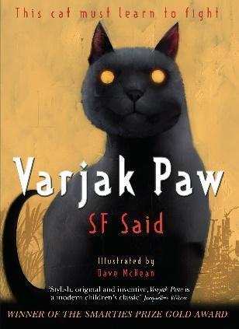 | 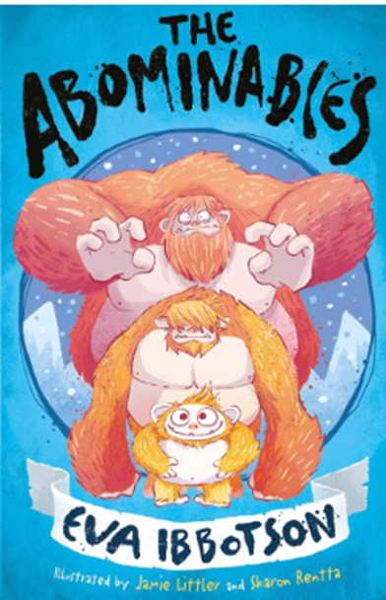 | 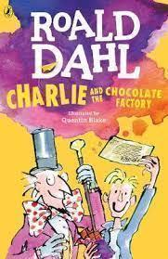 | 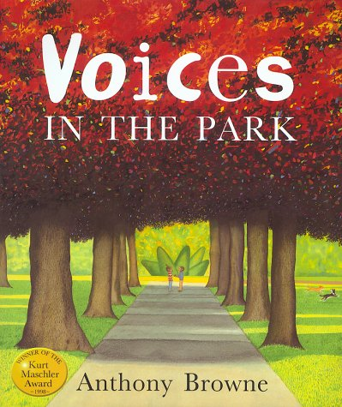 | 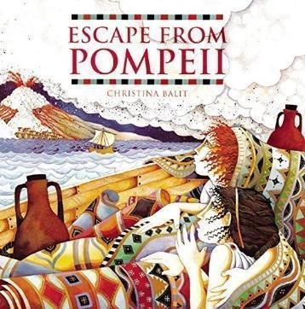 | 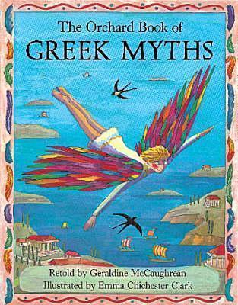
Purpose and outcome | To entertain/ inform  Adventure Story  Building suspense  Newspaper Reports | To inform/entertain  Mystery / suspense story.  Information texts. | To entertain  Dialogue and plays | To narrate/ entertain  Stories from familiar settings | To inform/entertain  Information, Informal Letters  Discussion text / balanced argument | To narrate/inform  Myths  Instructions
Poetry | Writing  Rhyme, personification, repetition  The River - Valerie Bloom  https://childrens.poetryarchive.org/poem/the-river/  Discuss the imagery in the poem  Explore personification and repetition | Write - Shape Rhythm, enjambment  Needles - by Brian Briston  https://brianbilston.com/2021/12/06/needles/ | performance  narrative poetry  Chocolate Cake by Michael Rosen  https://www.youtube.com/watch?v=tWrOeNKvtHI | write/alter to make it about a gorilla  Rhyme-  Lizzy’s Lizard - Denise Lee  https://childrens.poetryarchive.org/poem/lizzys-lion/ | learn by heart  Free verse  I have never seen "Volcanoes"  by Emily Dickinson  https://www.poetryfoundation.org/poems/159330/i-have-never-seen-volcanoes-175 | R.E Global World  neighbours  Our World - J.A.Shaw  https://cosmofunnel.com/poems/our-world-21287
Spoken Language | 1. Listen and respond appropriately to  adults and their peers  Be able to listen to complex information and work out most of the key information (some support  may be required to help them to work out the next steps)  e.g. ‘Tell your partner three facts about ... using the right words if you can and then write them  down.’  Recognise the cause and effect element of spoken instructions, that there may be consequences if  certain instructions are not followed  e.g. ‘Everyone needs to stop talking and listen now, otherwise we will be late for break.’  2. Ask relevant questions to extend their understanding and knowledge  Ask a range of different types of questions to find out specific information including ‘how’ and ‘why’  e.g. ‘How do we know this was from Ancient Roman times?’  Be aware of when they haven’t understood something because of the vocabulary used and ask a  general clarification question  e.g. ‘What does that long word mean?’  3. Use relevant strategies to build their vocabulary  Experiment with new vocabulary in different contexts to test out understanding and to learn from  mistakes  e.g. ‘The land around the arctic has no trees and is called the tundrum.’ (Meaning ‘tundra’)  4. Articulate and justify answers, arguments and opinions  Give reasons and explanations for choices and viewpoints in class discussions  e.g. ‘I think the ending of the book is better than the ending in the film because sometimes things  don’t work out well for people in real life.’  5. Give well-structured descriptions, explanations and narratives for different purposes, including for  expressing feelings  Tell a story with a clear structure including the setting and ideas linked in different ways  e.g. ‘On holiday me and Dad went to the seaside. It was great because Dad helped me build a  massive sandcastle which I decorated with shells and seaweed. I took a photo of it because after a  while the waves started washing it away.’  Discuss how a character may be feeling and why  e.g. ‘I think he might be feeling confused because he doesn’t understand why his cat has died.’  Able to use conjunctions to increase the length and grammatical complexity of sentences  e.g. ‘before, after, while, so’ |  |  | 6. Maintain attention and participate actively in collaborative conversations, staying on topic  and initiating and responding to comments  Able to initiate conversations with unfamiliar adults (in school or in a safe environment) and pupils.  7. Use spoken language to develop understanding through speculating, hypothesising, imagining and  exploring ideas  Understand how language is used to investigate and reflect on feelings e.g. ‘I feel sad because Jane is leaving. How do you feel?’  8. Speak audibly and fluently with an increasing command of standard English  Produce speech that is consistently clear and easy to understand.  Able to say words of any length with accuracy.  Use phonological awareness skills when spelling, although some mistakes may still be made. Try to spell words with 4 or more phonemes by listening to the sounds in the words.  Able to signal punctuation and emphasise meaning through the use of intonation e.g. pausing to divide speech into intelligible ‘chunks’ of meaning.  9. Participate in discussions, presentations, performances, role play, improvisations and debates  Respond to the opinions of others in the group  e.g. ‘Everyone on my table thinks the boy made the right choice. I agree with them.’  10. Gain, maintain and monitor the interest of the listener(s)  Able to initiate conversations with unfamiliar adults (in school or in safe environment) and pupils.  Exaggerate to make a story more interesting e.g. ‘I was so tired I could have slept for a week!’  11. Consider and evaluate different viewpoints, attending to and building on the contributions of others  Able to understand another’s point of view and show whether they agree or disagree  e.g. ‘I know why you think the boy is naughty but I don’t think he did it on purpose.’  12. Select and use appropriate registers for effective communication  Aware of the need to use more formal language with adults  e.g. ‘Please could I have another pencil?’ (to the teacher) or ‘Give me/pass me another pencil (to a peer).’
Reading | Background Knowledge: Connect readings to prior understanding experiences.  Vocabulary Knowledge: explore the meaning of unfamiliar words with increasing complexity.  Understanding Sentences: Analyse varied sentences and their impact on the reader. | Using Text Structure: Identify paragraphs and chapters.  Understand breaks a story into chapters and summarises.  Activating Meaning: explore how language and text structure add to meaning.  Use story maps and Venn diagrams.  Making Inferences: Infer character motivations.  Discuss characters' actions and reasons. | Background Knowledge: Connect texts to prior knowledge.  Relate readings to students' experiences.  Vocabulary Knowledge: Context to determine word meaning.  Use context clues to understand new words.  Understanding Sentences: Study sentence structures in texts. | Comprehension Monitoring: Self-questioning.  Summarising: Summarise paragraphs and chapters. Identify main points.  Critical Thinking: Discuss the author's purpose.  Analyse the author's intent and message. | Using Text Structure: Headings, subheadings, sections.  Identify and use text structures in non-fiction.  Activating Meaning: Context clues and text features.  Use glossaries and indexes for meaning.  Making Inferences: Textual evidence for inferences.  Support inferences with evidence. | Background Knowledge: Historical/cultural context.  Discuss the context of stories.  Vocabulary Knowledge: Identify and interpret figurative language.  Understanding Sentences: Impact of sentence structure.  Analyse how sentence structure affects meaning.
Grammar/ punctuation | Apostrophe  Commas  Inverted commas  Adverbials  Fronted adverbials  Conjunctions  Prepositions | Bullet Points  Capital Letters for proper noun  Adverbials  Fronted adverbials  pronoun and noun | Fronted adverbials  Expanded noun phrase  Types of Nouns  Proper nouns  Direct speech  Present perfect forms of verbs | Clause,  Subordinate clause  Adverbials and fronted adverbials  conjunctions  Prepositions  pronouns | Relative clauses  Commas  Rhetorical questions  tense | Apostrophe for possession  Commas Inverted  commas  Adverbials and  Conjunctions
Year 4 | 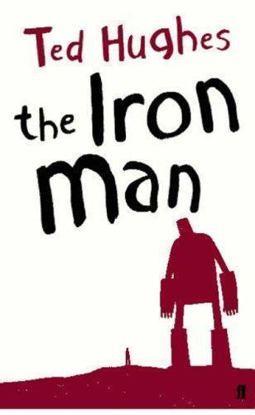 | 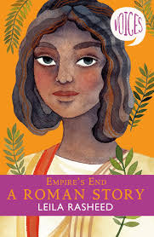 | 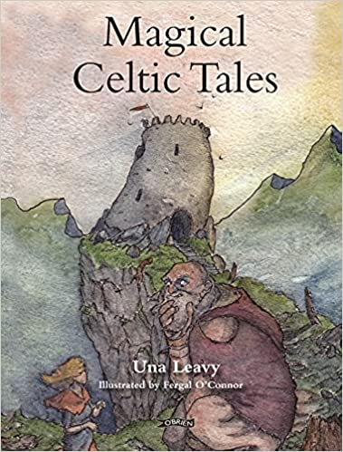 | 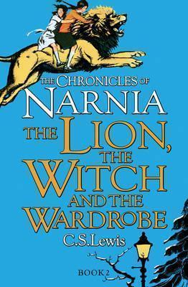 |  | 
Purpose and outcome | To inform/persuade  Newspapers  Letters of Persuasion | To entertain/recount  Stories with a historical settings  Diary extracts | To entertain/narrate  imagery poetry - Write | To narrate/ entertain/ debate  Stories with imaginary Worlds  Issues and Dilemmas | To inform/entertain  Explanation  Story from another country | To inform  Magazines  Information text  Persuasive leaflet
Poetry | Learn by heart  Rhyme/imagery  Roger the Dog - Ted hughes  https://poetrybyheart.org.uk/poems/roger-the-dog | learn by heart - Rhyme rhythm  T'was the Night Before Christmas - Clement Moore  https://poetry4kids.com/classics/a-visit-from-st-nicholas/ | Performance  Rhyme, Quatrain, 40 word poem  The Romans In Britain - Judith Nicholls  https://childrens.poetryarchive.org/poem/the-romans-in-britain/ | Write  rhyme personification and alliteration  Winter - Judith Nicholls  https://childrens.poetryarchive.org/poem/winter/ | learn by heart  Free verse  The Rhythm by James Carter  https://childrenspoetrysummit.com/tag/poems4kids/#:~:text=The%20Rhythm%0A%0AThere%E2%80%99s,the%20Wild) | R.E. - Global World  A need for Globalisation  A Poem on Globalization -  Kushagra Tewari  https://medium.com/@kushagratewari2/a-poem-on-globalization-and-need-for-globally-relevant-skills-3caa7aeeefd8
Spoken Language | 1. Listen and respond appropriately to adults and their peers  Listen to information, work out which elements are key and make relevant, related comments  e.g. ‘So we need to go home and ask people of different ages what telly was like when they were  young and work out how things have changed. I can ask my granny, my dad and my big sister.’  Infer meanings, reasons and make predictions  e.g. ‘Now, Class 4, I’m going to count to 10’ – i.e. ‘Mrs Jones is getting cross, we need to listen.’  2. Ask relevant questions to extend their understanding and knowledge  Able to use a series of questions to keep a conversation flowing  e.g. ‘Do you like science? What do you like most about science? Have you learned about food chains  yet?’  Be aware of when they can’t remember and ask for an explanation  e.g. ‘Is the author the one that writes the story and the illustrator does the pictures?’  3. Use relevant strategies to build their vocabulary  Identify clearly when they haven’t understood/can’t remember specific vocabulary and can ask  questions to clarify their understanding  e.g. ‘What do we call a ghost again, is it a spectator or a spectre?’  4. Articulate and justify answers, arguments and opinions  Use complex grammar and sentences effectively to clarify, summarise, explain choices and plan  e.g. ‘We decided that Jenny would go first because she’s the fastest and would get us a good start.’  5. Give well-structured descriptions, explanations and narratives for different purposes, including for  expressing feelings  Tell a story with a good structure and a distinct plot, including an exciting event with a clear  resolution and end point.  Describe events at home or school clearly including key details, a clear narrative structure and  linking behaviours with emotions such as nervous, worried, angry, cross, frustrated, pleased  e.g. ‘I shouted because I was angry.’  Able to use fronted adverbials to increase the length and grammatical complexity of sentences  e.g. ‘Later that day, I heard the bad news.’ |  |  | 6. Maintain attention and participate actively in collaborative conversations, staying on topic and initiating and responding to comments  Able to sustain a conversation by giving reasons and explaining choices and views  e.g. ‘I think we should start sorting out these pictures so we can stick them onto the paper. If we use  the Pritt stick it will be quicker than using the other glue.  7. Use spoken language to develop understanding through speculating, hypothesising, imagining and  exploring ideas  Able to discuss cause and effect  e.g. ‘If you hold the bowl still, I’ll be able to pour the mixture in with two hands. That way I won’t spill  any of it.’  8. Speak audibly and fluently with an increasing command of standard English  Produce speech that is consistently clear and easy to understand.  Able to say words of any length with accuracy.  Secure phonological awareness skills.  Identify the sounds in a word, the number of syllables and rhyming words and use this in my reading and spelling.  Use formal language when appropriate in some familiar situations  e.g. showing a visitor around school, using language such as ‘Excuse me’, ‘I’m pleased to meet you’  and speaking in full sentences.  9. Participate in discussions, presentations, performances, role play, improvisations and debates  Able to take on group roles to discuss with peers  e.g. able to act as the chairperson or the note taker in a group  10. Gain, maintain and monitor the interest of the listener(s)  Add or omit detail according to how much is already known by the listener  e.g. ‘Peter was in big trouble last evening when he didn’t put Munchkin, that’s our pet rabbit, away.’  When I talk to people, I usually know how much information they need.  Use intonation to give added emphasis  e.g. ‘Helpful?’, she cried, ‘You must be joking!’  11. Consider and evaluate different viewpoints, attending to and building on the contributions of others  Able to identify and reflect on key points of what they have just been told  e.g. ‘So our flag is called the Union flag and not the Union Jack. The flagpole is the jack, they always  call it that on the TV.’  12. Select and use appropriate registers for effective communication  Understand and use popular colloquial expressions e.g. ‘That’s sick!’
Reading | Using Text Structure: Story elements and patterns.  Identify story patterns in texts.  Vocabulary Knowledge: Understand that words add meaning to the text. Use the text to gain meaning of unfamiliar words.  Understanding Sentences: Explore how different sentences have an impact on meaning. | Background Knowledge: Cross-curricular connections.  Read stories related to other subjects.  Making Inferences: Use textual evidence.  Find evidence to support inferences.  Vocabulary Knowledge: Study and verbally use advanced vocabulary. | Making Inferences: Infer from text and pictures.  Discuss inferences based on textual evidence.  Understanding Sentences: Analyse grammar and sentence structure and how they add to the meaning of the text.  Using Text Structure: Analyse different genres with poetry.  Explore the text structures. | Vocabulary Knowledge: Analyse figurative language.  Study figurative language in texts.  Understanding Sentences: Impact of sentence structure.  Discuss how sentence structure affects meaning.  Critical Thinking: Analyse themes.  Identify themes in texts and discuss. | Background Knowledge: Discuss thematic connections.  Relate readings to themes in other subjects.  Vocabulary Knowledge:  Learn new words through context.  Understanding Sentences: Analyse grammar and sentence structure and how they add to the meaning of the text. | Activating Meaning: Use glossaries/indexes.  Find information using text features.  Background Knowledge: Historical and cultural context.  Relate stories to historical events.  Comprehension Monitoring: Summarise main events and question how they connect.
Grammar/ punctuation | Bullet Points  Capital Letters for proper noun  Adverbials  Fronted adverbials  Rhetorical questions | Clause,  Subordinate clause  Adverbials and fronted adverbials  conjunctions  Prepositions | Commas  Clauses  Pronouns  Prepositions  Adverbials  Types of nouns | Fronted adverbials  Expanded noun phrase  Proper nouns  Direct speech | Apostrophe for possession  Commas Inverted  commas  Adverbials and  Conjunction | Apostrophe  Commas  Inverted commas  Adverbials  Fronted adverbials  Conjunctions  Prepositions
Year 5 | 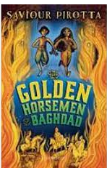 | 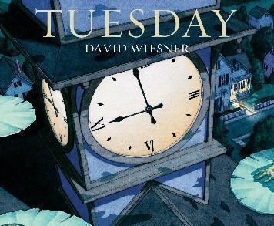 | 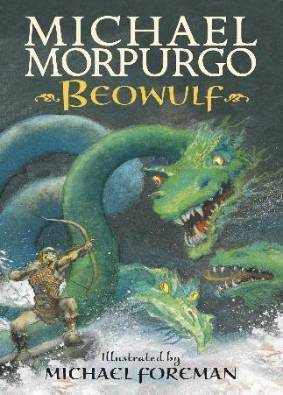 | 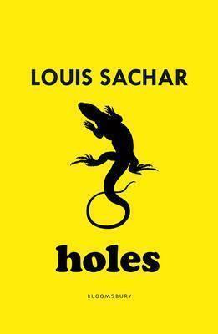 | 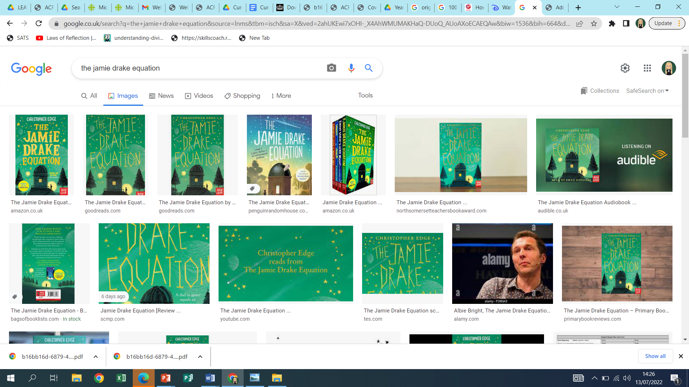 | 
Purpose and outcome | To inform/entertain  recounts/Newspaper  Story from another culture | To inform  More complex Instructions | To entertain/narrate  Legendspoetry - poetic style Persuasion (contrary argument | To inform/ debate  Recounts  Arguments  Film Narrative | To entertain  Dramatic Conventions | To entertain  Historical stories
Poetry | Write  Free verse - rhyme/ repetition  I am Brave - Laura Mucha  https://childrens.poetryarchive.org/poem/i-am-brave/ | Learn by heart  Rhyme, imagery  Mistletoe  BY WALTER DE LA MARE  https://www.poetryfoundation.org/poems/57833/mistletoe | Explore  Beowulf the Old English poem | writing  rhyme and riddle poems  The Bluebottle - Judith Nicholls  https://childrens.poetryarchive.org/poem/bluebottle/  Listen to the poem being read  Explore rime/ the final syllable of a word | performance  Rhyme/imagery/metaphor  Cosmic Disco by Grace Nichols  https://childrens.poetryarchive.org/poem/cosmic-disco/ | R.E. - Global World  performance - environmental issue  The World We Created Poem by Theo Williams  https://www.poemhunter.com/poem/the-world-we-created-2/
Spoken Language | 1. Listen and respond appropriately to adults and their peers  Listen to complex information and identify key elements and make relevant, related comments  e.g. ‘Everyone needs to find a partner and then collect a kit. You will need two flasks, 100 ml of water  and some food dye. You will need to take two colours for each group, but the groups can share if  there are not enough to go around. Decide who’s going to collect what, and if you need to share  colours, and then wait until I tell you what to do next.’  Actively use inference, prediction and reasoning skills by looking for the underlying meaning of  what has been said e.g. ‘You said there was no milk left but I can see a full jug on the table. You are teasing me!’  2. Ask relevant questions to extend their understanding and knowledge  Use follow up questions linked to answers that have just been given  e.g. ‘When did you ...?’, ‘What happened ... ?’, ‘Why did you ... ?’  Ask a clarification question that requires the speaker to elaborate on what they have said  e.g. ‘Could you explain again how that works?’  3. Use relevant strategies to build their vocabulary  Incorporate topic vocabulary into their written and spoken work  e.g. ‘Everything is made up of atoms, like solids, liquids and gases.’  4. Articulate and justify answers, arguments and opinions  Able to use complex sentences and link by meaning to present ideas logically  e.g. ‘We travelled to France for our holiday and enjoyed the journey on the ferry because there was a  soft play area and we were allowed to drink coke.’  5. Give well-structured descriptions, explanations and narratives for different purposes, including for  expressing feelings  Include a subplot in telling stories and recalling events before resolving the main storyline.  Present a point of view using persuasive language  e.g. ‘Please come to my party – it will be awesome! We are having a really funny clown and the  biggest bouncy castle in the world.’  Use complex sentences and conjunctions to link ideas together in order to present ideas logically  e.g. ‘The boy fell over in the park; however he did not need to go to hospital because his injuries were  not serious.’  6. Maintain attention and participate actively in collaborative conversations, staying on topic and initiating and responding to comments  Able to use and respond to a range of strategies such as asking questions or making relevant  comments to keep a conversation flowing. |  |  | 7. Use spoken language to develop understanding through speculating, hypothesising, imagining and  exploring ideas  Able to use complex sentences and to present ideas logically  e.g. ‘The easiest way to get to the gym is going through the big hall which is on the left as you leave  this room. Then turn right and it is the third door on the left.’  Able to use language to persuade  e.g. ‘Do you want to be part of something that helps people who have lost everything? Then join my  fantastic fundraising group and you can make a difference to someone’s life.’  8. Speak audibly and fluently with an increasing command of standard English  Produce speech that is consistently clear and easy to understand.  Able to say words of any length with accuracy.  Secure phonological awareness skills.  Identify the sounds in a word, the number of syllables and rhyming words and use this in my reading and spelling.  Use appropriately different words and phrases, from how people in that area normally talk, and  standard English  e.g. ‘we were’ instead of ‘we was’, or ‘I did’ instead of ‘I done’.  9. Participate in discussions, presentations, performances, role play, improvisations and debates  Able to take turns, listening carefully to others and politely agreeing or disagreeing with them I can listen carefully to others and politely agree or disagree with them.  Able to present a point of view by presenting evidence and using persuasive language with familiar  topics  e.g. ‘I think we could all go out in the snow because we all have boots, coats, gloves and hats and if we  get some fresh air now we will be able to concentrate better on our work when we come back.’  10. Gain, maintain and monitor the interest of the listener(s)  Realise when the listener doesn’t fully understand and try to help them I can repeat or re-phrase what I have said to help someone understand me.  Is able to use humour effectively.  11. Consider and evaluate different viewpoints, attending to and building on the contributions of others  Actively use inference, prediction and reasoning skills by looking for the underlying meaning of  what has been said  e.g. ‘Are we going to Disneyland? You said there would be a brilliant surprise and you keep smiling  and looking at Dad.’  12. Select and use appropriate registers for effective communication  Use appropriately different words and phrases, from how people in that area normally talk, and standard English  e.g. ‘we were’ instead of ‘we was’, or ‘I did’ instead of ‘I done’.
Reading | Using Text Structure: Identify chapters and sections.  Summarise chapters.  Activating Meaning: Use context clues to determine meanings.  Making Inferences: Infer themes and messages.  Discuss themes based on textual evidence. | Vocabulary Knowledge: Study synonyms and antonyms, and how they add to our understanding of a text/ picture.  Critical Thinking: Analyse author’s purpose.  Discuss the author's intent and message.  Making Inferences: Find evidence to support inferences. | Background Knowledge: Historical/cultural context.  Discuss context and themes in texts.  Vocabulary Knowledge: Study and use advanced vocabulary.  Comprehension Monitoring: Summarise text and self-question.  Making Inferences: Find evidence to support inferences. | Summarising: Summarise multi-paragraph texts, identifying the main points.  Making Inferences: Find evidence to support inferences.  Using Text Structure: Compare structures across genres. | Vocabulary Knowledge: Identify and interpret figurative language.  Understanding Sentences: Sentence structure impact.  Activating Meaning: Use context clues to determine meanings. | Background Knowledge: Historical/cultural context.  Discuss context and themes in texts.  Making Inferences: Find evidence to support inferences.  Activating Meaning: Use context clues to determine meanings.
Grammar/ punctuation | Vocabulary & structures for  various purposes; expanded  noun phrases; modal verbs;  contrasting conjunctions;  conditional statements;  present perfect tense;  fronted adverbials of time. | Commas to clarify meaning or avoid ambiguity in writing;  cohesive devices to build  (within) and link ideas across paragraphs;  hyphens to avoid ambiguity; varied sentence openers  Relative clauses. | Personification; suffixes (-ful and  -less); adverbs; adverbial;  fronted adverbial;  adverbial  phrases; commas; verbs;  adjectives;  past tense; past perfect tense. | Vocabulary & structures  appropriate for formal speech &  writing, inc subjunctive forms;  expanded noun phrases to  convey complicated  information concisely; modal  verbs or adverbs to indicate  degrees of possibility; emotive  vocabulary. | Brackets, dashes or commas  to indicate parenthesis;  Relative clauses; semicolons,  or dashes to mark boundaries  between independent  clauses; punctuating bullet  points consistently. | Emotive language; brackets,  dashes or commas to indicate  parenthesis;  fronted adverbial;  adverbial phrases;  commas; verbs;  adjectives; past tense.
Year 6 | 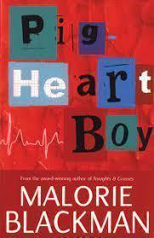 | 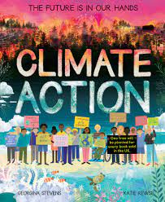 | 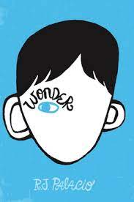 |  | 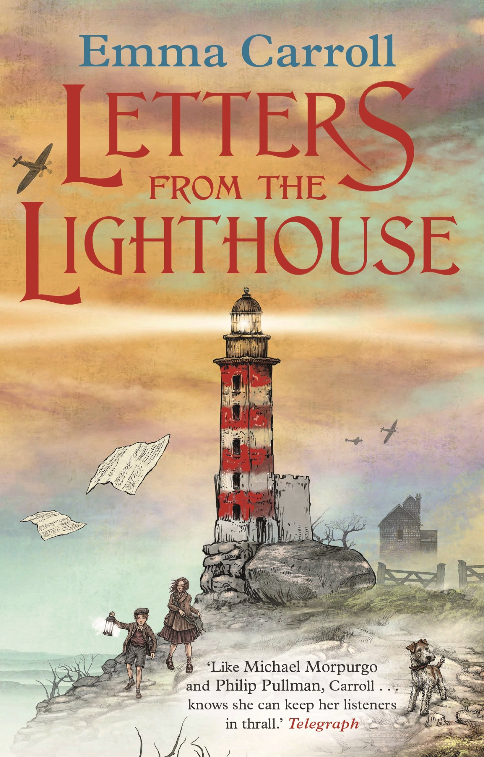
Supporting Texts | Harry potter and the philosophers stone/The Maya | Newspapers/Percy Jackson and the Lightning Thief by Rick Riordan | Thomas edison biography/A city through time by Steve Noon | Nelson Mandela - Long walk to Freedom/ Bradley Wiggins biography | Rose Blanche/Resuing children by Deborah Hodge | Anne Frank Autobiography/war horse/Goodnight Mr Tom
Purpose and outcome | To persuade  flashbacks, Balanced/unbalanced arguments | To inform/entertain  Action stories,  Journalistic writing, | To entertain  Poetry - imagery, Time slips | To inform  Biography,  Formal writing, | To inform/entertain  Letters, Playscripts | To inform/entertain  Auto-Biography, legend  Comparative discussion with a similar text
Poetry | Write  Structured verse-repetition  Give and Take - Roger McGough  https://clpe.org.uk/poetry/poems/give-and-take  Hard copy and author reading | Learn by heart  Dialect  Christmas Come -An- Gorn  - John- Lyons  https://childrens.poetryarchive.org/poem/christmas-come-an-gorn/ | Write  Free verse - inference - difference  Michael - Matt Goodfellow  https://clpe.org.uk/videos/video/matt-goodfellow-michael  Read by Matt Goodfellow | Learn by heart  Quatrain  Lament of An Arawak Child by Pamela Mordecai  https://poetrybyheart.org.uk/poems/lament-of-an-arawak-child | performance  Rhyme, questions  THE EVACUEE by Arthur E. King  https://www.bbc.co.uk/history/ww2peopleswar/stories/83/a2011483.shtml | R.E. Global world  Environment issues  Repetition - alliteration - free verse  Better world  https://crhs.sch.im/site/uploads/blog/206/_media/20201007_a7a8ada7/A_Better_World_Poems.pdf
Spoken Language | 1. Listen and respond appropriately to  adults and their peers  Understand the key points made by a number of speakers and to compare different points of view.  Appreciate sarcasm when it is obvious  e.g. ‘My best vase, broken. Now that was really clever.’  2. Ask relevant questions to extend their understanding and knowledge  Understand and use different types of questions: open, closed, rhetorical I can understand and use lots of different types of questions.  Identify clearly when they haven’t understood and be specific about what additional information  they need  e.g. ‘So what is the difference between transparent and translucent?’  3. Use relevant strategies to build their vocabulary  Use ‘academic’ vocabulary (i.e. ‘Tier 2’ words e.g. co-operate, analyse) but the meaning might not be  accurate  e.g. ‘I had to cooperate really hard to get my work done.’  4. Articulate and justify answers, arguments and opinions  Able to use language to negotiate with others, to explain options available and to predict possible  outcomes.  e.g. ‘I will put these maths books away if you will collect the pencils. This will be quicker.’  5. Give well-structured descriptions, explanations and narratives for different purposes, including for  expressing feelings  Tell elaborate entertaining stories which are full of detailed descriptions with varied vocabulary.  Share ideas and information, give and receive advice, offer and take notice of the opinion of others  e.g. ‘I think it would be a good idea to use a different colour pen so it stands out.’ or ‘We could  strengthen the towers like this, but I think your way will work better.’  Use long and complex sentence structures in class and other situations  e.g. ‘I will come with you only because it means that you will stop hassling me.’  6. Maintain attention and participate actively in collaborative conversations, staying on topic and initiating and responding to comments  Able to share ideas and information, give and receive advice, offer and take notice of the opinion of others  e.g. ‘I think the boy was being mean to the girl but you are right when you said that she was being  mean to him first.’ |  |  | 7. Use spoken language to develop understanding through speculating, hypothesising, imagining and  exploring ideas  Use inference, reasoning and prediction skills  e.g. ‘I know you don’t mean that because I have seen the other class lining up.’  Able to negotiate an agreement explaining other options and possible outcomes  e.g. ‘Ok, let’s try the carpet first, as most of us think that will cause most friction; but the rubber mat is  quite sticky and if we are wrong then the other team will win.’  8. Speak audibly and fluently with an increasing command of standard English  Produce speech that is consistently clear and easy to understand.  Able to say words of any length with accuracy.  Secure phonological awareness skills and identify the sounds in a word, the number  of syllables and rhyming words and use this in  my reading and spelling.  Able to rephrase what they want to say according to the audience  e.g. in more formal situations use ‘discover’ for ‘find out’, ‘request’ for ‘ask for’ etc.  9. Participate in discussions, presentations, performances, role play, improvisations and debates  Able to share ideas and information, give and receive advice, offer and take notice of the opinion of others  e.g. ‘I think the boy was being mean to the girl but you are right when you said that she was being  mean to him first.’  Able to present a point of view by presenting evidence and using persuasive language with academic topics  e.g. ‘If we all recycled more, we wouldn’t need to use as much energy to make new things, so it would  be better for the planet.’  10. Gain, maintain and monitor the interest of the listener(s)  Able to share ideas and information, give and receive advice, offer and take notice of the opinion of others  e.g. ‘I think the boy was being mean to the girl but you are right when you said that she was being  mean to him first.’  Sophisticated use of different types of questions to help conversation flow.  11. Consider and evaluate different viewpoints, attending to and building on the contributions of others  Able to reflect on several people’s opinions or suggestions and summarise or suggest a compromise  e.g. I think we should all go swimming first but make sure you have enough money for the bus fare  home.’  12. Select and use appropriate registers for effective communication  Able to rephrase what they want to say according to the audience  e.g. in more formal situations use ‘discover’ for ‘find out’, ‘request’ for ‘ask for’ etc.
Reading | Background knowledge: Integrate with current events.  Discuss how texts relate to contemporary issues.  Vocabulary Knowledge: Analyse nuanced language.  Understanding Sentences: Sentence structure analysis. | Background Knowledge: Cross-curricular readings.  Relate texts to other subjects  Discuss how texts relate to current events.  Vocabulary: Study and use advanced vocabulary.  Critical Thinking: Analyse and discuss texts critically.  Engage in critical discussions about texts. | Vocabulary Knowledge: Explore how the meaning of words add impact to the story..  Understanding Sentences: Complex sentence analysis.  Explore how the position of words adds to their meaning and changes their word class.  Critical Thinking: Analyse and discuss texts critically.  Engage in critical discussions about texts. | Background Knowledge: Connect to current events.  Discuss how texts relate to current events.  Comprehension Monitoring: Ask reflective questions about texts.  Making Inferences: Justify inferences with evidence.  Provide evidence to support inferences.  Summarising: Summarise key points from multiple texts. | Background Knowledge: Relate texts to historical/cultural contexts.  Vocabulary Knowledge: Identify and interpret figurative language.  Understanding Sentences: Complex structure impact.  Analyse how sentence structure impacts meaning. | Making Inferences: Discuss deeper themes and messages.  Comprehension Monitoring: Ask reflective questions about texts.  Critical Thinking: Evaluate text critically.  Critically analyse and discuss texts.
Grammar/ punctuation | Brackets, dashes or commas to indicate parenthesis;  Relative clauses;  semicolons, colons or dashes to mark boundaries between  independent clauses;  punctuating bullet points  consistently. | Passive Voice; modal verbs; dashes for independent clauses;  hyphens;  cohesive devices; perfect form of  verb; relative clauses  Use of the passive to affect the presentation of information in a  Sentence. | Using a colon to introduce  a list;  use of figurative language; organisational  and presentational  devices to structure text;  viewpoint (2nd person). | Vocabulary & structures appropriate for formal speech & writing, inc  subjunctive forms;  expanded noun phrases to convey complicated information concisely;  modal verbs or adverbs to indicate degrees of possibility  varied sentence types for effect  and impact. | Commas to clarify meaning or avoid  ambiguity in writing;  cohesive devices to build (within) and link ideas across paragraphs;  hyphens to avoid ambiguity;  varied sentence openers  varied sentence types for effect  and impact. | Use of the passive to affect the presentation of information in a  Sentence;  varied sentence types for effect  and impact.

Oracy Across the Curriculum
English:
Encourage discussions about texts, including character motivations, plot development, and themes.
Use drama and role-play to explore and understand literature.
Math:
Explain mathematical reasoning and problem-solving processes.
Use mathematical language accurately in discussions.
Science:
Discuss hypotheses, experiments, and results.
Present scientific information clearly and accurately.
History and Geography:
Debate historical events and geographical issues.
Present research findings and engage in discussions about different perspectives.
Art and Design:
Critique and discuss artworks, using appropriate vocabulary.
Present and explain creative ideas and processes.
Physical Education:
Use spoken language to give and follow instructions in games and activities.
Discuss strategies and evaluate performances.
PSHE (Personal, Social, Health, and Economic Education):
Engage in discussions about personal and social issues.
Express opinions and listen to the views of others with respect.
P4C
Engage in discussions about philosophical issues.
Express opinions and listen to the views of others with respect.
Debate different opinions and perspectives.
Explore increasingly more complex concepts like identity, existence, and knowledge through structured dialogue.

